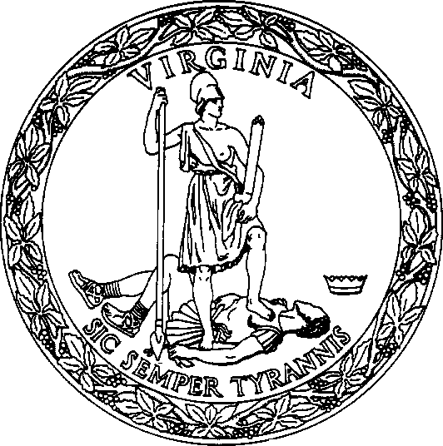
COMMONWEALTH OF VIRGINIA STATE CORPORATION COMMISSION

LPA-73.11:3 CERTIFICATE OF LIMITED PARTNERSHIP OF A VIRGINIA OR FOREIGN (12/19) PARTNERSHIP CONVERTING TO A VIRGINIA LIMITED PARTNERSHIP
The undersigned, on behalf of the partnership set forth below, pursuant to Title 50, Chapter 2.1 of the Code of Virginia, state(s) as follows:
- The name of the former partnership, the jurisdiction under whose law it was formed immediately prior to the filing of this certificate of limited partnership, and its SCC ID number, if assigned, are

.
- (Mark this box only if applicable:) □ The former partnership is registered with the Commission as a registered limited liability partnership.
- The partners have approved the conversion of the partnership to a limited partnership in accordance with the provisions of § 50-73.11:3 B of the Code of Virginia.
- The name of the limited partnership is

.
(see instructions for name requirements)
- (Mark if applicable:) □ The partnership was previously authorized or registered with the Commission to transact business in Virginia as a foreign business entity. (See instructions.) Set forth the additional required information on an attachment.
- A. The name of the limited partnership’s initial registered agent is .
  - The registered agent is (mark appropriate box):
    - an INDIVIDUAL who is a resident of Virginia and
      - a general partner of the limited partnership.
      - an officer or director of a corporation that is a general partner of the limited partnership.
      - a general partner of a general or limited partnership that is a general partner of the limited partnership.
      - a member or manager of a limited liability company that is a general partner of the limited partnership.
      - a trustee of a trust that is a general partner of the limited partnership.
      - a member of the Virginia State Bar.

OR
    - □ a domestic or foreign stock or nonstock corporation, limited liability company or registered limited liability company authorized to transact business in Virginia.
- A. The limited partnership’s initial registered office address, including the street and number, if any, which is identical to the business office of the initial registered agent, is

VA .
(number/street) (city or town) (zip)
  - The registered office is physically located in the □ county or □ city of .
- The name and post office address, including the street and number, if any, of each general partner and, if it is a business entity, the jurisdiction under whose laws it is incorporated, organized or formed, and its SCC ID number, if assigned, are:

(name of general partner) (SCC ID #, if assigned) (jurisdiction of organization)

(number/street) (city or town) (state) (zip)

(name of general partner) (SCC ID #, if assigned) (jurisdiction of organization)

(number/street) (city or town) (state) (zip)

Check and complete if applicable:
□ Each of the following general partners that is a business entity is serving, without more, as a general partner of the limited partnership and does not otherwise transact business in Virginia. See §§ 13.1-757, 13.1-1059 and/or 50-73.61 of the Code of Virginia.

- The limited partnership's principal office address, including the street and number, if any, is
.
(number/street) (city or town) (state) (zip)

[OVER]

Signed on behalf of the former partnership by the following partner:

(signature) (printed name) (date)
Signature(s) of all general partners of the resulting partnership:
(telephone number (optional))

(signature) (printed name and title) (date)

(signature) (printed name and title) (date)
PRIVACY ADVISORY: Information such as social security number, date of birth, maiden name, or financial institution account numbers is NOT required to be included in business entity documents filed with the Office of the Clerk of the Commission. Any information provided on these documents is subject to public viewing.

INSTRUCTIONS TO FORM LPA-73.11:3
This form is to be used to convert an existing partnership (commonly referred to as a “general partnership”) to a Virginia limited partnership.
The certificate must be in the English language, typewritten or printed in black on white, opaque paper 8 1/2" by 11" in size, legible and reproducible, and free of visible watermarks and background logos. A minimum of 1" must be provided on the left, top and bottom margins and 1/2" on the right margin. Use only one side of a page.
This form may be modified to provide for additional general partner listings and signatures. You can download this form from our website at www.scc.virginia.gov/clk/formfee.aspx.
If the partnership was previously authorized or registered with the Commission to transact business in Virginia as a foreign corporation, limited liability company, business trust, limited partnership or registered limited liability partnership, with respect to every such prior authorization or registration, set forth, on an attachment, the name of the entity, the entity’s type, the state or other jurisdiction of incorporation, organization or formation; and the SCC ID number that was assigned to the entity by the Commission.
The conversion must be approved by the partners of the partnership in the manner provided in the partnership agreement for amendments to the partnership agreement or, if no such provision is made in the partnership agreement, by all of the partners.
The name of the limited partnership must contain the words "Limited Partnership" or "a Limited Partnership," the abbreviation "L.P." or “LP.” However, if the limited partnership is also applying for status as a registered limited liability partnership pursuant to § 50-73.132 of the Code of Virginia, the name must include either (1) (a) the words “limited partnership” or “a limited partnership,” or the abbreviation “L.P.” or “LP” and (b) the words “Registered Limited Liability Partnership” or “Limited Liability Partnership,” the abbreviation “R.L.L.P.” or “L.L.P.” or the designation “RLLP” or “LLP,” or (2) the words “Registered Limited Liability Limited Partnership” or “Limited Liability Limited Partnership,” the abbreviation “R.L.L.L.P.” or “L.L.L.P.” or the designation “RLLLP” or “LLLP.” See § 50-73.2 of the Code of Virginia.
The proposed limited partnership name must be distinguishable upon the records of the Commission. See § 50-73.2 of the Code of Virginia. To check the availability of a limited partnership name, please contact the Clerk’s Office Call Center at (804) 371-9733 or toll-free in Virginia at (866) 722-2551.
A limited partnership may not serve as its own registered agent.
The registered office address must be identical to the registered agent’s business office address, must be located in Virginia, and must include a street and number if one is associated with the location. A rural route and box number may only be used if no street address is associated with the location of the registered office. A post office box is only acceptable for towns/cities that have a population of 2,000 or less when no street address or rural route and box number is associated with the location of the registered office. Set forth the name of the county or independent city in which the registered office is physically located. Counties and independent cities in Virginia are separate local jurisdictions.
If a general partner is a business entity, this certificate must include the jurisdiction under whose laws the general partner is incorporated, organized or formed, and, if the general partner is of record in the Clerk’s Office of the State Corporation Commission, the SCC ID number assigned to the general partner. See § 50-73.11 A 3 of the Code of Virginia.
The principal office is the office, in or out of Virginia, where the principal executive offices of the limited partnership are located. It is also a place of its business, at which is kept a current list of the full name and last known address of each general partner of the limited partnership, as well as the other limited partnership information and records specified in § 50-73.8 of the Code of Virginia. See §§ 50-73.1 and 50-73.4 of the Code of Virginia.
The principal office address must be a complete post office address, including a street and number, if any. A rural route and box number may only be used if no street address is associated with the principal office’s location. A post office box is not acceptable, as it cannot meet the foregoing requirements of a principal office.
This certificate must be signed on behalf of the converting partnership and by all of the general partners. Each person signing this certificate must set forth his or her printed name next to or beneath his or her signature. IMPORTANT: A person signing on behalf of a general partner that is a business entity should set forth the business entity’s name, his or her printed name, and the capacity in which he or she is signing on behalf of the business entity. Any person may sign a certificate by an attorney-in-fact. See § 50-73.15 B of the Code of Virginia.
It is a Class 1 misdemeanor for any person to sign a document he or she knows is false in any material respect with the intent that the document be delivered to the Commission for filing. See § 50-73.15 C of the Code of Virginia.
Submit the original, signed certificate to the Clerk of the State Corporation Commission, P.O. Box 1197, Richmond, Virginia 23218- 1197, (Street address: 1300 East Main Street, Tyler Building, 1st floor, Richmond, Virginia 23219), along with a check for the filing fee in the amount of $100.00, payable to the State Corporation Commission. PLEASE DO NOT SEND CASH. If you have any questions, please call (804) 371-9733 or toll-free in Virginia, (866) 722-2551.

This certificate can be filed online in real time by visiting our website at https://cis.scc.virginia.gov.

